Week 4 Continuation of Learning May 04-08, 2020.
Grade 3 Belyea

Hello everyone,
This week our Continuation of Learning plan has been designed around suggestions given to teachers from ASD-W. Many resources are being added for teachers to use in their weekly planning. I think you will really enjoy the activities.

On Wednesdays I will be checking my email, from 10-11 am to answer any questions you may have. I really like what parents are doing at home and appreciate your support.
Reminders:
In addition to the activities suggested, students are encouraged to:
- Read daily for 30 minutes- Take time to read to or with your child and encourage them to read independently.
Scholastic Read at home: divided up by day 1, 2 etc.., with activities and reading.
This is a great link for SCIENCE
2.https://classroommagazines.scholastic.com/support/learnathome/grades-1-2.html Grades1-2
https://classroommagazines.scholastic.com/support/learnathome/grades-3-5.html Grades 3-5

3. EPIC books- available during the day
https://www.getepic.com/ - Our class code is zgc2046
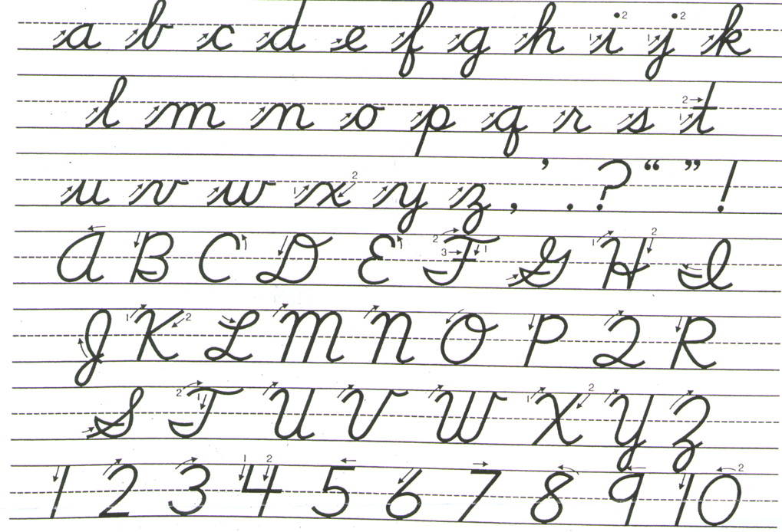
Please practise cursive writing for a few minutes each day. Practise makes perfect!

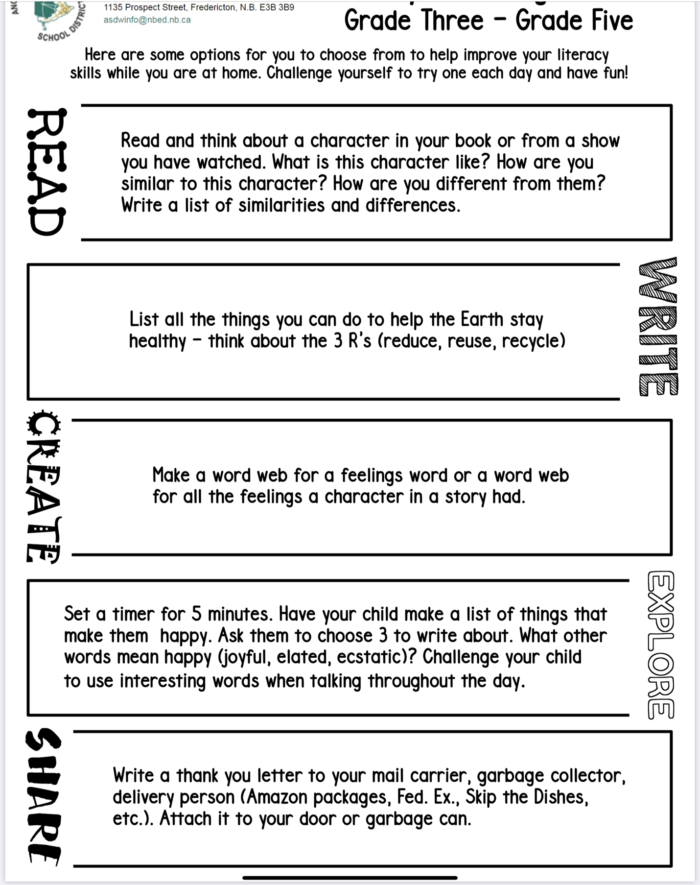
Grade 3 Literacy Activities

Gr 3 Choice Board -Number Sense
Please choose an activity to each day.
Roll a die 3 times(or use number cards) to create a three digit number. Print your number on your score card that fits the description. Compare your answers with a partner score card.  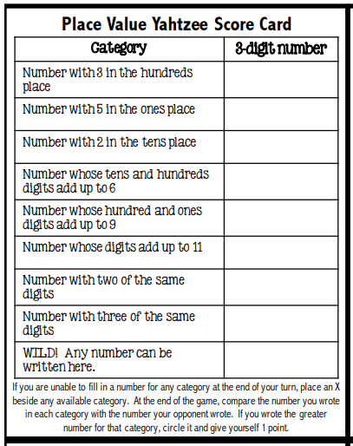 | You have a total of $1.45 in coins in your pocket. What are all the possible combinations of coins you could have . | Solve Me  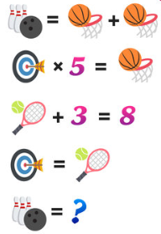  For more puzzles try:  https://mashupmath.com/blog/math-logic-puzzles-for-kids
Here is a short sequence of numbers.  Can you figure out the rule and fill  in the next three blanks?  2, 3, 5, 7, ___, ____, ____  Remember, what’s important is not which numbers you pick, but rather how you explain your answer. | Strike Out.  Draw a number line from 0-20  Player 1 chooses 2 numbers on the line that they want to find the sum or the difference of. They cross out the two numbers, find the sum or difference and circle the answer. Record the equation. Player 2 will begin with the circled number and choose another number not crossed out yet to either add or find the difference from and circle their answer. Players continue to take turns beginning where the previous player finished and using only numbers that have not been crossed off yet. The winner of the game is the player who stops their opponent from making a move.  Below is an example of three moves that were made on a number line and their recording.  4+3=7  7-1=6  6+12=18 | Flip Three  Using a deck of cards with face cards removed set all of the cards in rows face down.  Players take turns to flip over three cards and attempt to make an equation using the three cards. The equation can be an addition, subtraction, multiplication or division, e.g. 3+3=6, 8-5=3, 2×1=2, 10÷2=5.  If the player can make an equation they keep the cards. If they can’t make an equation the cards are flipped back over in the same place.  Continue playing until only 7 cards remain. The winner is the player who has the most cards.
How many triangles can you find?  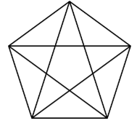 | 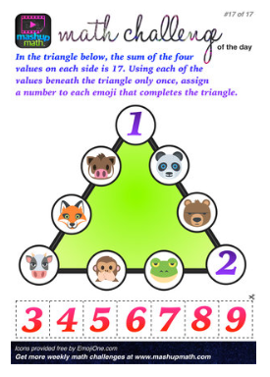 | 